Test Bar Codes for the Interleaved 2 of 5 Symbology

Some scanners have difficulty reading bar codes with the Interleaved 2 of 5 symbology. Sometimes, the number is read incorrectly, or some of the digits are just not read at all, so you get a truncated number. It turns out that this bar code symbology is not very robust.

Bar code applications should recognise most misreads, but some accept the wrong numbers without complaining. In order to minimise undetected errors, it is best to configure the scanner to only accept the bar code formats you will actually be using, with the exact number length and only with a correct check digit (MOD 10).

I am using the following bar codes to test the number length and check digit configuration.

Note that the Interleaved 2 of 5 symbology is only defined for an even number of digits.

Number  of digits | With correct  check digit | With incorrect  check digit
2 digits | 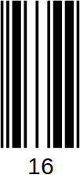 | 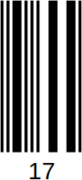
4 digits | 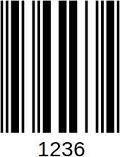 | 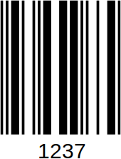
6 digits | 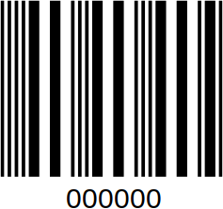 | 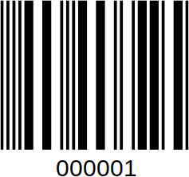
8 digits | 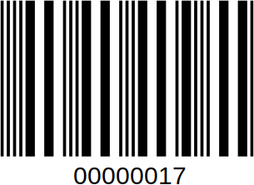 | 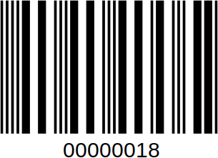

Author: R. Diez. Version 1.0. This document is licensed under the Creative Commons Attribution-ShareAlike 4.0 International License (CC BY-SA 4.0).

